Practical lesson 4 : Morphology and classification of viruses, protozoa and fungi.
Morphology and classification of fungi
Fungus is a member of a large group of eukaryotic organisms that includes microorganisms such as yeasts and molds (British English: moulds), as well as the more familiar mushrooms. These organisms are classified as a kingdom, Fungi, which is separate from plants, animals, protists and bacteria. One major difference is that fungal cells have cell walls that contain chitin, unlike the cell walls of plants and some protists, which contain cellulose, and unlike the cell walls of bacteria. These and other differences show that the fungi form a single group of related organisms, named the Eumycota (true fungi or Eumycetes), that share a common ancestor (is a monophyletic group). This fungal group is distinct from the structurally similar myxomycetes (slime molds) and oomycetes (water molds). The discipline of biology devoted to the study of fungi is known as mycology. Mycology has often been regarded as a branch of botany, even though it is a separate kingdom in biological taxonomy. Genetic studies have shown that fungi are more closely related to animals than to plants.
Fungi are eukaryotic microorganisms. Fungi can occur as yeasts, molds, or as a combination of both forms (dimorphic).The fungi are marked by various morphology. The main structural component of the vegetative body is the mycelium which is composed of branching colourless filaments (hyphae). In some species the mycelium is non-septate, i.e. formed of a single cell (Mucor mould),in others (higher fungi) its polycellular (septate).
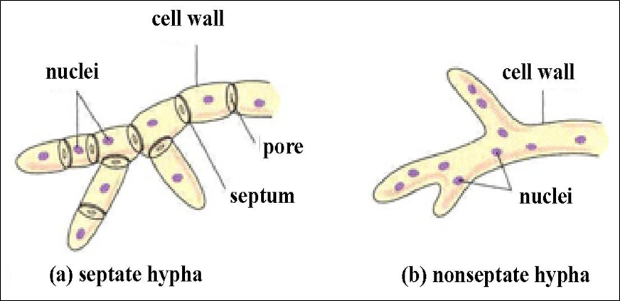
Fungi resemble algae in structure. They have a firm membrane consisting of cellulose, pectin substances, and carbohydrates. Another feature of fungi is the presence of chitin in their cell walls . The chitin adds rigidity and structural support to the thin cells of the fungus. Various inclusions are found in the cytoplasm: glycogen, volutin, drops of fat.Yeasts are fungi that grow as solitary cells that reproduce by budding. Yeast taxa are distinguished on the basis of the presence or absence of capsules (exception - Cryptococcus neoformans), the size and shape of the yeast cells, the mechanism of daughter cell formation (conidiogenesis), the formation of pseudohyphae and true hyphae, and the presence of sexual spores. Yeasts such as C albicans and Cryptococcus neoformans produce budded cells known as blastoconidia.
Fungi are usually classified according to biological taxonomy based upon the type of hypha, spore and reproduction. There are four classes of fungi.

Class Phycomycetes. The algal fungi: bread molds and leaf molds. The only known mycosis (fungal disease) caused by fungi of this class is mucormycosis, a very rare fungal growth of the upper respiratory tract, bronchial mucosa, and lungs. It occurs largely as a complication of a chronic, debilitating disease, such as uncontrolled diabetes.
Class Ascomycetes. The sac fungi: yeasts, mildews, and cheese molds. Fungi of this class are implicated in only three fungus diseases, all of which are rare.
The genus Aspergillus belongs to the class Ascomycetes. The fungi have divided septate mycelium, and a unicellular conidiophore which terminates in a fan-like row of short sterigmata from which the spores are pinched off in chains — conidia (Gk. konidion particle of dust).
A typical representative of aspergilla is Aspergillus niger which is widespread in nature. It is found on moist objects, on bread and jam. Certain species may cause aspergillosis of the lungs, ear, and eye in humans or may infect the whole body.
The genus Penicillium belongs to the class Ascomycetes. The mycelium and conidiophore are multicellular while the fruiting body is in the shape of a brush. The conidiophore branches towards its upper part and terminates in sterigmata from which even-rowed chains of conidia are pinched off. This genus of fungi is widespread in nature. It is found in fodder, milk products, ink and jam, on moist objects, and old leather. The type species is Penicillium glaucum.
Basidiomycetes, fungi with a multicellular mycelium. These organisms predominantly reproduce sexually by basidiospores (basi-dia — reproductive organs in which a certain number of spores develop, usually). Smut fungi invade grain crops causing a disease known as smut. Rust fungi affect sunflowers, and other plants. They produce orange-coloured sports on infected plants.
Deuteromycetes (Fungi imperfecti) are a rather large group of fungi consisting of a multicellular mycelium without either the asco- or basidio-sporangiophore, but only with conidia. Reproduction is asexual, sexual reproduction is unknown.

Morphology and Ultrastructure of Protozoa.
Protozoa (Gk. protos first, zoon animal) are unicellular animal organisms more highly organized than bacteria. They have a cytoplasm, a differentiated nucleus, a cell wall which differs in optical properties, and primitive organelles.
Protozoa reproduce by simple and multicellular division, sexually, and also by a more complicated process — sexually and asexually (malarial plasmodium). Three types of locomotory organelles may be present. One or more long flagella may be present. Cilia, shorter and more numerous than flagella are present in some taxa. Flagella and cilia aid in swimming. Pseudopodia, temporary extensions of the cytoplasm which elongate the plasma membrane, permit enable crawling.
Most protozoans pass through at least two distinct morphological forms during their life cycle. Much of the terminology for these forms is specific to particular taxa. Some terms are fairly general. Feeding stages are termed trophozoites, and these may reproduce asexually. Trophozoite (Greek for “animal that feeds”) is a general term for the active, feeding, multiplying stage of most protozoa.Transmission stages enclosed within a membrane to resist conditions in the external environment are called cysts. Stages which are about to reproduce sexually and form gametes are called gametocytes. Amoebae, lamblias and balantidia can produce cysts.
The basic body organization of protozoans consists of an external plasma membrane which encloses the cytoplasm and nucleus . There may be one or more nuclei, and in some taxa the nuclei are of two types: larger macronuclei and smaller micronuclei.
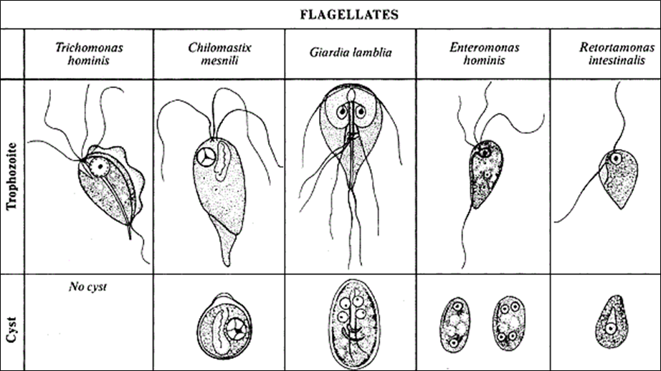Organelles present within the cytoplasm that are visible by light microscopy are few. Vacuoles containing food material in various states of digestion may be present, and mitochondria are occasionally large enough to be seen. Representatives of certain species have two or more nuclei. The phylum Protozoa can be subdivided into 5 classes: Flagellata, Sarcodina (Rhizopoda), Apicomplexa, Microspora, Ciliophora.

Morphology and classification of viruses
The name virus (L. virus poison) was given by Pasteur to many causative agents of infectious diseases and by Beijerinck to the causative agent of tobacco mosaic disease.
Viruses are small obligate intracellular parasites, which by definition contain either a RNA or DNA genome surrounded by a protective, virus-coded protein coat . The cell wall or the special surface membrane has been named a capsid as it is composed of a certain amount of capsomers. The number of structural capsomers in the capsid of a given virus is constant (32 in the poliomyelitis virus, 252 in the adenovirus, 2000 in the tobacco mosaic disease virus, etc.). A complete virus particle is called a virion. The main function of the virion is to deliver its DNA or RNA genome into the host cell so that the genome can be expressed (transcribed and translated) by the host cell. Viruses do not have a cellular structure and are small in size, varying over a wide range from 20 to 350 nm.
The viral genome, often with associated basic proteins, is packaged inside a symmetric protein capsid. The nucleic acid-associated protein, called nucleoprotein, together with the genome, forms the nucleocapsid. In enveloped viruses, the nucleocapsid is surrounded by a lipid bilayer derived from the modified host cell membrane and studded with an outer layer of virus envelope glycoproteins.
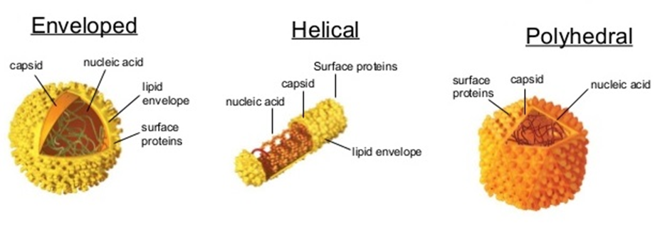
Viral structure and shapes

The size of viruses can be determined by filtration through colloid membranes, centrifugation in high-speed centrifuges, and electron microscopy.
Symmetry (the property of bodies to repeat their parts) is an important feature in the structure of virions. Viruses have no enantiomorphic protein molecules, their symmetric packings have only axes of symmetry. A symmetry axis is a straight line on rotation about which to a definite angle a figure coincides with itself. According to the character of the packing of the protein subunits, viruses are subdivided into two types of symmetry: spiral and cubic. In spiral symmetry the packing of the subunits turns into a closed cylindrical pattern. In cubic symmetry the lines of the curve of the tightly packed hexagonal subunit layer will be straight lines stretching at an angle of 120 degrees in relation to one another. The elements of the surface are equilateral triangles.
A single-strand RNA molecule is located between protein subunits. The viruses of influenza, parainfluenza, and others and others belong to the spiral type of symmetry.
Viruses with cubic symmetry have the shape of a polyhedron (tetrahedron, hexahedron, dodecahedron, icosahedron); these are the causative agents of poliomyelitis, papilloma, and herpes, adenoviruses, etc.
Some viruses are marked by combined symmetry, having an intermediate layer ('inner' capsid) possessing a different type, between the 'outer' capsid and the nucleoid; certain phages (T2, T4, T6), the vaccinia virus, etc. belong to this group.
In a number of virus infections intracellular inclusions are formed. Many of them are well discerned under a light microscope, and they are employed for laboratory diagnosis of rabies, smallpox and other diseases.
Viruses are obligate parasites. They live and multiply in the cells of live organisms (lower and higher plants, arthropods, wild and domestic animals and man), but are also able to develop in homogenates of different tissues and organs.

Property | Viruses | Cells
Type of nucleic acid | DNA or RNA but not both | DNA and RNA
Proteins | Few | Many
Lipoprotein membrane | Envelope present in some viruses | Cell membrane present in all cells
Ribosomes | Absent | Present
Mitochondria | Absent | Present in eukaryotic cells
Enzymes | None or few | Many
Multiplication by binary fission or mitosis | No | Yes
Figure 59. Comparison of viruses and cells

Morphology. Viruses are grouped on the basis of size and shape, chemical composition and structure of the genome and mode of replication. Helical morphology is seen in nucleocapsids of many filamentous and pleomorphic viruses. Helical nucleocapsids consist of a helical array of capsid proteins (protomers) wrapped around a helical filament of nucleic acid. Icosahedral morphology is characteristic of the nucleocapsids of many “spherical” viruses. The number and arrangement of the capsomeres (morphologic subunits of the icosahedron) are useful in identification and classification. Many viruses also have an outer envelope .
Chemical Composition: The genome of a virus may consist of DNA or RNA, which may be single stranded (ss) or double stranded (ds), linear or circular. The entire genome may occupy either one nucleic acid molecule (monopartite genome) or several nucleic acid segments (multipartite genome). The different types of genome necessitate different replication strategies.
1. Spherical form. This includes the viruses of influenza, parotitis, Japanese encephalitis, measles, arboviruses and other viruses. The size of viruses having a spherical shape varies within the range of 18 to 150 nm.
2. Rod-shaped form. This includes the causative agents of tobacco mosaic disease, potato blight, etc. They are 300 nm in length and 15 nm in width.
3. Cuboidal form. This form is characteristic of the vaccinia (cowpox) virus, the viruses of smallpox and papillomas of humans and animals, adenoviruses, enteroviruses, reoviruses, etc. Their size ranges between 30 and 350 nm.
4. Spermatozoid form. It is characteristic for viruses of the lower plants (phages). Their size varies from 47-104 to 10-225 nm.
